STUDENT INQUIRY HANDOUT • 42-MINUTE PERIOD
2D Projectile Motion: Video Tracking & Kinematics Analysis
AP Physics C: Mechanics • Laboratory Investigation • Platform: Lab-ove and Beyond by MR. F.

Course: AP Physics C (Mechanics) | Period / Block: ________ | Class Duration: 42 Minutes
Student Name: _____________________ | Lab Partner: _____________________ | Date: ________________________

Objective: Track 2D projectile motion in Lab-ove and Beyond. Calibrate scale, measure kinematics parameters, fit linear and quadratic curves to extract g, and apply calculus to analyze trajectory extrema.
■ AP PHYSICS C: UNIFORMLY ACCELERATED MOTION (UAM) REFERENCE FORMULAS
(1) $v = v_{0} + a·t$ (3) $v^{2} = v_{0}^{2} + 2a·Δx$
(2) $Δx = v_{0}·t + \frac{1}{2}a·t²$ (4) $Δx = (\frac{v_{0} + v}{2})·t$
* Note: Apply component-wise with ax = 0 (horizontal) and ay = -g (vertical). No further equations are provided.

Your 42-Minute Clock
The five steps below add up to 42 minutes (17 of 25 points). Section 4 is an optional homework extension (8 points).
Class Time | Lab Phase | What You Actually Do | Pts
0:00 - 0:04 (4m) | 1. Set Up & Calibrate | Load 'FizziQ: Parabolic Motion (Classic Lab)' (30.0 FPS, Δt = 0.0333 s). Ruler tool: click both ends of the 1.00 m rod and enter 1.00 m. Origin tool: click the ball at Frame 0, then set +Y up and +X downrange. | —
0:04 - 0:14 (10m) | 2. Track & Record | Autotrack (⚡) the ball across the 25 tracked frames, then export the CSV. Copy x, y, vx, vy and v into the 5-milestone data table. | 1
0:14 - 0:25 (11m) | 3. Physical Measurements | Section 2 - Q2.1 launch speed, angle and vector (3 pts). Q2.2 derive & predict apex/range, then measure and verify (3 pts). Q2.3 mid-ascent vectors, direction angle and a∥ / a⊥ (3 pts). | 9
0:25 - 0:35 (10m) | 4. Graphs & Curve Fits | Section 3 - x(t) linear fit and ax (2 pts). y(t) quadratic fit, g_exp and % error (3 pts). vy(t) fit comparison and the y(x) trajectory shape (2 pts). | 7
0:35 - 0:42 (7m) | 5. Check & Submit | Verify every answer carries SI units and the correct sign. Compare your fitted values with the app readouts. Staple the handout and submit. | —
42 minutes | CORE TOTAL | Required work that is graded during the period. | 17
+25 min outside class (25m) | 6. Optional Extension | Section 4 - AP Physics C calculus challenges: C4.1 trajectory derivation (3 pts), C4.2 position integration & impact velocity vector (3 pts), C4.3 minimum-speed extremum (2 pts). Not required to finish the 42-minute lab. | 8

■ HOW TO SPEND THE PERIOD
● REQUIRED items are the 42-minute core: Steps 1-5 and Sections 2-3. Finish and submit these today.
◇ OPTIONAL EXTENSION items are Section 4 (Challenges 4.1-4.3). They need about 25 more minutes as homework; nothing in Section 4 is needed to finish class today.
Pace yourself: if the clock reaches 0:25, you should already be starting Section 2.

1. What to Do on the 'Lab-ove and Beyond' App
■ APP WORKFLOW PROTOCOL
1. Load Video: Top navbar → 'Video Library' → select 'FizziQ: Parabolic Motion (Classic Lab)' (30.0 FPS, Δt = 0.0333 s).
2. Calibrate Scale (📐 Ruler Tool): Click Ruler tool. Click bottom and top of the 1.00 m rod on left → Enter '1.00 m'.
3. Set Origin (🎯 Axes Tool): Click Origin tool. Click projectile center at Frame 0 (release point). Set +Y Up and +X Downrange.
4. Track Motion (✛ Crosshair / ⚡ Autotracker): Click projectile center across all 25 frames from release (t = 0.00 s) to landing.
5. Vectors (👁️): Toggle Velocity and Acceleration overlays to inspect vector magnitude and direction live.

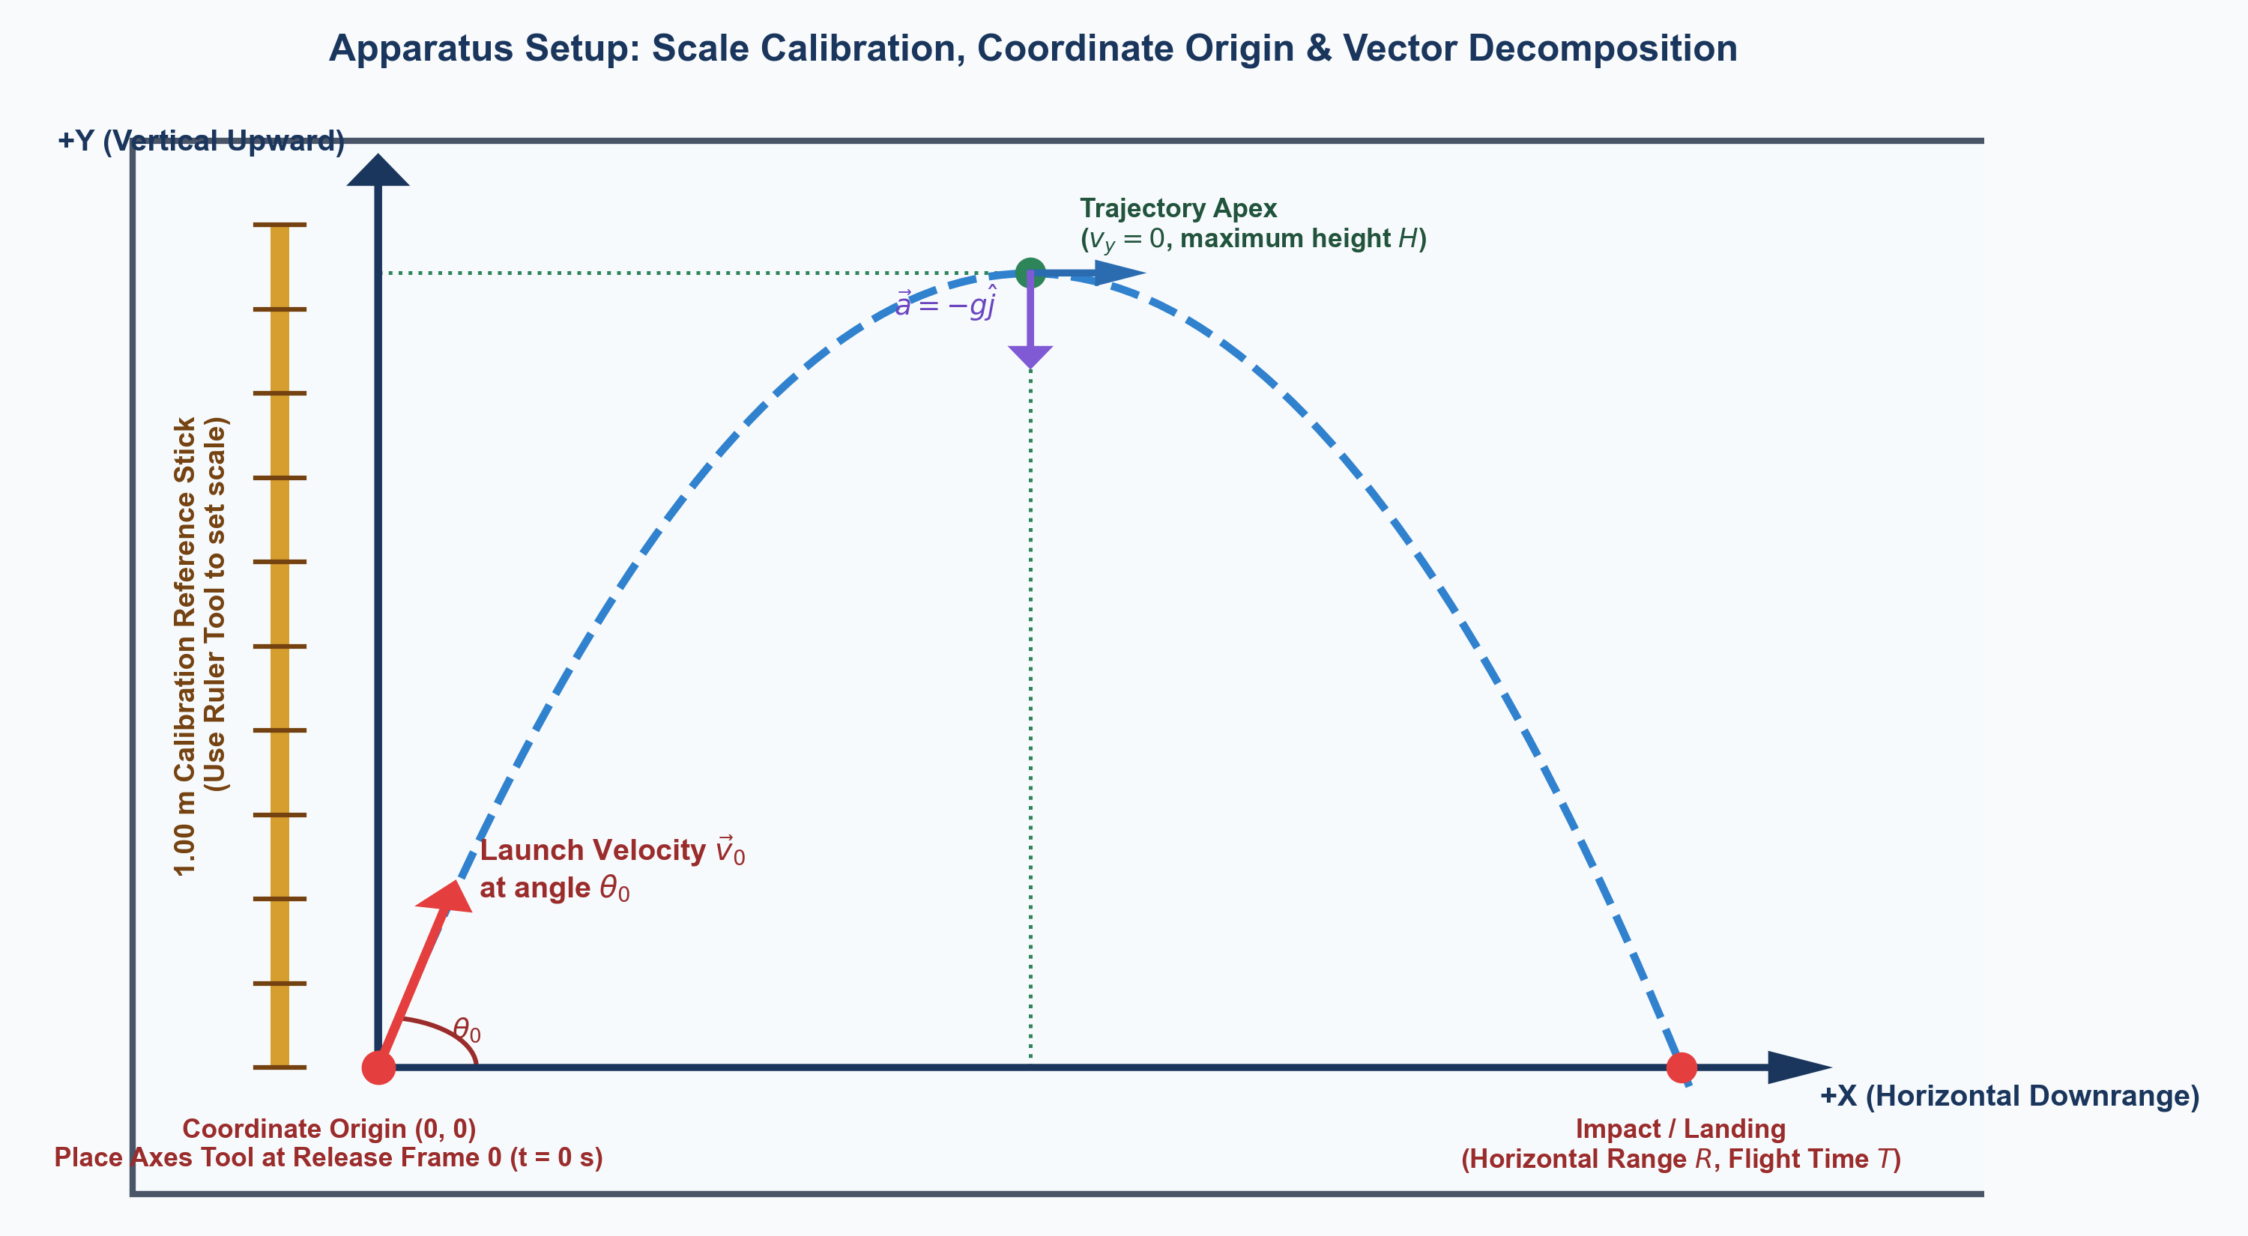
Figure 1: Lab-ove and Beyond experimental interface: 1.00 m calibration stick, launch origin (0,0), and coordinate axes.

2. Physical Measurements (Data Acquisition)
Read instantaneous values by hovering on tracked points or opening the Table view. Record the 5 key milestones:
Trajectory Milestone | Frame | Time t (s) | x (m) | y (m) | vx (m/s) | vy (m/s) | Speed v (m/s)
1. Launch / Release | 0 | 0.000 | 0.000 | 0.000
2. Mid-Ascent | 6 | 0.200
3. Apex (Peak Height) | 13 | 0.433 |  |  |  | ≈ 0.00
4. Mid-Descent | 18 | 0.600
5. Landing / Impact | 24 | 0.800
● REQUIRED — counted in the 42-minute core | budget about 4 min | 3 pts
Question 2.1 [Launch Velocity & Angle — 3 Points]:
(a) Initial Launch Speed [1 Pt]: Using your measured launch velocity components at Frame 0 (t = 0.00 s), determine the initial launch speed $v_{0}$.
✍ Show formula, values, and calculated v0 in m/s:

(b) Launch Angle [1 Pt]: Determine the launch angle $θ_{0}$ above the horizontal.
✍ Show formula, values, and calculated θ0 in degrees:

(c) Launch Vector [1 Pt]: Express the launch velocity vector $\vec{v}(0)$ in Cartesian unit-vector notation (î, ĵ).
✍ Write v(0) with numerical components and units:

● REQUIRED — counted in the 42-minute core | budget about 4 min | 3 pts
Question 2.2 [Derive First & Predict Extrema, Then Measure & Verify — 3 Points]:
(a) Apex Time & Maximum Height: Algebraic Derivation & Prediction [1 Pt]: Starting from the 4 UAM equations at the top, algebraically derive symbolic formulas for apex time $t_{apex}$ and maximum height H in terms of vertical launch component $v_{0y}$ and g. Substitute your measured launch component and g = 9.81 m/s² to predict their numerical values before checking your video data.
✍ Show algebraic UAM derivations for tapex and H, then calculate predicted values:

(b) Total Flight Time & Range: Algebraic Derivation & Prediction [1 Pt]: Starting from the 4 UAM equations, algebraically derive symbolic formulas for total flight duration T and horizontal range R on level ground in terms of launch velocity components and g. Calculate your theoretical predictions.
✍ Show algebraic UAM derivations for T and R, then calculate predicted values:

(c) Video Data Measurement & Verification [1 Pt]: Now inspect your tracked data in Lab-ove and Beyond. Read and record measured H and $t_{apex}$ at Frame 13, and measured R and T at Frame 24. Calculate the percent error between your theoretical predictions and video measurements. Does the flight exhibit symmetry?
✍ State measured values (Frames 13 & 24), compute % errors, and evaluate symmetry:

● REQUIRED — counted in the 42-minute core | budget about 3 min | 3 pts
Question 2.3 [Instantaneous Vector Kinematics at Mid-Ascent (t = 0.200 s) — 3 Points]:
(a) Position & Velocity Vectors [1 Pt]: At t = 0.200 s (Frame 6), state position vector $\vec{r}(0.20)$ and velocity vector $\vec{v}(0.20)$ in unit-vector notation.
✍ Write r(0.20) and v(0.20) in unit-vector notation:

(b) Direction of Motion [1 Pt]: Determine the instantaneous direction angle ϕ of travel above the horizontal at this instant.
✍ Show formula and calculate direction angle ϕ in degrees:

(c) Acceleration Components [1 Pt]: Decompose the acceleration due to gravity into its tangential component $a_{∥}$ and normal component $a_{⊥}$. Explain the physical effect of each component on the projectile's motion.
✍ Derive and compute a_parallel and a_perp (m/s²) with physical explanations:

3. How to Draw & Fit Graphs in the App
1. Open Graphs: Switch to 'Graphs' tab (or Split View).
2. Select Variables: Plot 'x', 'y', 'vy', and 'Trajectory y(x)'.
3. Apply Fits: Click 'Curve Fit' (📈) → choose 'Linear Fit' or 'Quadratic Fit'.
● REQUIRED — counted in the 42-minute core | budget about 3 min | 2 pts
Question 3.1 [Graph 1: Horizontal Motion x(t) Linear Fit — 2 Points]:
(a) Linear Regression Equation & $R^{2}$ [1 Pt]: Plot x(t), apply a linear fit, and record your regression equation and $R^{2}$ value.
✍ State x(t) regression equation and R² value:

(b) Slope Interpretation & Acceleration [1 Pt]: What physical quantity does the slope represent? What does this result prove about horizontal acceleration $a_{x}$? Justify using calculus.
✍ Explain slope meaning and deduce ax using calculus:

● REQUIRED — counted in the 42-minute core | budget about 4 min | 3 pts
Question 3.2 [Graph 2: Vertical Motion y(t) Quadratic Fit & g Extraction — 3 Points]:
(a) Quadratic Regression Equation & $R^{2}$ [1 Pt]: Plot y(t), apply a quadratic fit (y = At² + Bt + C), and record your regression equation and $R^{2}$ value.
✍ State y(t) quadratic regression equation and R² value:

(b) Gravitational Acceleration Extraction [1 Pt]: Using your quadratic fit and UAM kinematics, determine your experimental acceleration due to gravity $g_{exp}$. Show your work and reasoning.
✍ Show derivation and calculate g_exp in m/s²:

(c) Percentage Error [1 Pt]: Calculate the percentage error of your experimental value relative to standard g = 9.81 m/s².
✍ Calculate percentage error:

● REQUIRED — counted in the 42-minute core | budget about 3 min | 2 pts
Question 3.3 [Graph 3 & 4: Velocity vy(t) Fit & Trajectory y(x) — 2 Points]:
(a) Vertical Velocity Fit [1 Pt]: Plot vy(t), apply a linear fit, and compare your experimental slope and vertical intercept to theoretical expectations.
✍ State vy(t) equation and compare slope and intercept to theory:

(b) Trajectory Shape & Air Drag [1 Pt]: Plot the spatial trajectory y(x). Describe the shape and evaluate whether real-world aerodynamic drag causes any observable deviation near landing.
✍ Describe 2D trajectory shape and note any real-world drag deviations:

◇ OPTIONAL EXTENSION — not needed to finish the 42-minute lab | budget about 25 min | 8 pts
4. Optional Extension: AP Physics C Free-Response Calculus Challenges
◇ OPTIONAL EXTENSION — not needed to finish the 42-minute lab | budget about 8 min | 3 pts
Challenge 4.1 [Calculus Trajectory Derivation & Path Verification — 3 Points]:
(a) Parametric Trajectory Derivation [1 Pt]: Starting from the horizontal and vertical position functions x(t) and y(t), eliminate time t to derive the symbolic trajectory equation y(x) in terms of $v_{0x}, v_{0y}, and g$.
✍ Show complete algebraic steps to eliminate time t and derive y(x):

(b) Numerical Trajectory Equation [1 Pt]: Using your experimental launch data, evaluate the coefficients and write the numerical equation for your trajectory y(x).
✍ Write numerical equation y(x) with evaluated coefficients:

(c) Apex Condition via Calculus [1 Pt]: Using calculus, determine the horizontal coordinate of the apex $x_{apex}$ by finding the extremum of y(x). Calculate its value and compare to your data table.
✍ Apply derivative condition to find x_apex and compare to data table:

◇ OPTIONAL EXTENSION — not needed to finish the 42-minute lab | budget about 9 min | 3 pts
Challenge 4.2 [Calculus Definite Integration: Vertical Position Integral & Impact Vector — 3 Points]:
(a) Position Integral & Maximum Height [1 Pt]: Starting from the vertical velocity function vy(t) = $v_{0y} - gt$, use definite calculus integration y(t) = $∫ vy(t') dt'$ to derive y(t). Prove that evaluating the integral over [0, $t_{apex}$] rigorously yields the maximum height formula.
✍ Show definite calculus integration steps to find y(t) and prove H:

(b) Impact Velocity Vector [1 Pt]: At landing time T, evaluate velocity components vx(T) and vy(T). Express the landing velocity vector $\vec{v}(T)$ in Cartesian unit-vector notation (î, ĵ).
✍ Evaluate landing components and write v(T) in unit-vector notation:

(c) Impact Angle & Kinetic Energy Conservation [1 Pt]: Determine the impact angle $θ_{impact}$ below the horizontal. Compare impact speed |v(T)| to launch speed v0. Justify why speed is conserved using the Work-Energy Theorem.
✍ Calculate θ_impact, compare |v(T)| vs v0, and justify with Work-Energy Theorem:

◇ OPTIONAL EXTENSION — not needed to finish the 42-minute lab | budget about 8 min | 2 pts
Challenge 4.3 [Calculus Extremum: Minimum Speed During 2D Flight — 2 Points]:
(a) Speed Optimization [1 Pt]: Express the square of the projectile speed v²(t) as a function of time. Using calculus, determine the exact time t* at which the speed reaches a minimum.
✍ Formulate v²(t), differentiate with respect to t, and solve for t*:

(b) Minimum Speed Value & Verification [1 Pt]: Determine the magnitude of the minimum speed $v_{min}$ and explain its physical significance. Compare with your experimental speed measurement at the apex.
✍ State v_min, explain physical meaning, and compare to apex data:

5. Student Evaluation Rubric (25 Points = 17 Core + 8 Extension)
Section | Performance Criteria | Max Pts | Score
CORE · App Setup & Data Table | Video loaded, 1.00 m rod calibrated, origin set at Frame 0, 5 milestones recorded | 1
CORE · Section 2: Physical Measurements | Q2.1 launch speed/angle/vector (3), Q2.2 derive & predict apex/range, then verify (3), Q2.3 mid-ascent vectors (3) | 9
CORE · Section 3: App Graphing & Fits | Q3.1 x(t) fit & ax (2), Q3.2 y(t) fit & g extraction (3), Q3.3 vy(t) & trajectory (2) | 7
CORE SUBTOTAL | Everything above is required and due at the end of the 42-minute period | 17
EXTENSION · Section 4: Calculus Challenges | Optional homework, not needed to finish the lab: C4.1 (3), C4.2 position integral & impact (3), C4.3 (2) | 8
TOTAL SCORE | AP Physics C Mechanics Laboratory Investigation Grade | 25

